Background

***Over $2 billion has been raised using the massively successful crowdfunding service, Kickstarter, but not every project has found success. Of the more than 300,000 projects launched on Kickstarter, only a third have made it through the funding process with a positive outcome.***

***Getting funded on Kickstarter requires meeting or exceeding the project's initial goal, so many organizations spend months looking through past projects in an attempt to discover some trick for finding success. For this week's homework, you will organize and analyze a database of 4,000 past projects in order to uncover any hidden trends.***

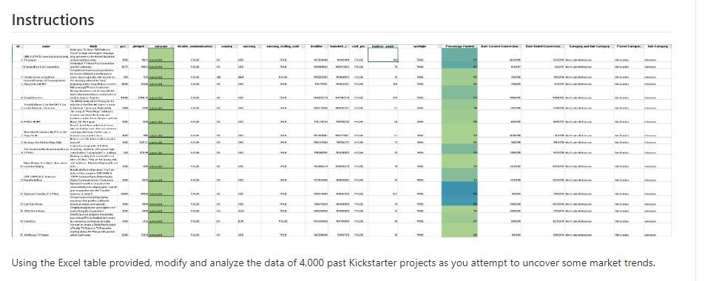

Using the Excel table provided, modify and analyze the data of 4,000 past Kickstarter projects as you attempt to uncover some market trends.

1. Use conditional formatting to fill each cell in the state column with a different color, depending on whether the associated campaign was successful, failed, or canceled, or is currently live.

Answer: See Col F

1. Create a new column O called Percent Funded that uses a formula to uncover how much money a campaign made to reach its initial goal.

Answer: See Col O

=Pledge/Goal * 100

format to %

1. Use conditional formatting to fill each cell in the Percent Funded column using a three-color scale. The scale should start at 0 and be a dark shade of red, transitioning to green at 100, and blue at 200.

1. Create a new column P called Average Donation that uses a formula to uncover how much each backer for the project paid on average.

Answer: See Col P

1. Create two new columns, one called Category at Q and another called Sub-Category at R, which use formulas to split the Category and Sub-Category column into two parts.

Answer: See Col S and Col T

1. Create a new sheet with a pivot table that will analyze your initial worksheet to count how many campaigns were successful, failed, canceled, or are currently live per category.

See spreadsheet: Tab Count Campaign by Catg

1. Create a stacked column pivot chart that can be filtered by country based on the table you have created.

See spreadsheet: Tab filter by country and catg

1. Create a new column named Date Created Conversion that will use this formula to convert the data contained within launched_at into Excel's date format.

Answer : See Col

1. Create a new column named Date Ended Conversion that will use this formula to convert the data contained within deadline into Excel's date format.

Answer : See Col J

1. Create a new sheet with a pivot table with a column of state, rows of Date Created Conversion, values based on the count of state, and filters based on parent category and Years.

See spreadsheet: Filter by Country, Parent Catg and Year

1. Now create a pivot chart line graph that visualizes this new table.

See spreadsheet: Tab Count Line Graph

1. Given the provided data, what are three conclusions we can draw about Kickstarter campaigns?

* For campaign by Category, theater campaign has the highest success by amount 839 in pledge where as technology category has the highest canceled pledges as compared to the remaining 9 categories
* Filter by category by country, US has the highest successful pledge than the overall countries (especially in film and theater categories) and SG with almost zero record of any pledge contribution
* As indicated in the line graph, there is a steady decline in pledge success and increase in failed pledges

1. What are some limitations of this dataset?

Volume of the data presented as tried to be presented in charts can lead to misinterpretation of which can result in making poor conclusion.

1. What are some other possible tables and/or graphs that we could create?

* 100% Stacked line: To show % contribution by bakers
* Pie Chart: To show % failed, success, live
* Bar Chart: To show failed, success, live….compare goal vs pledged